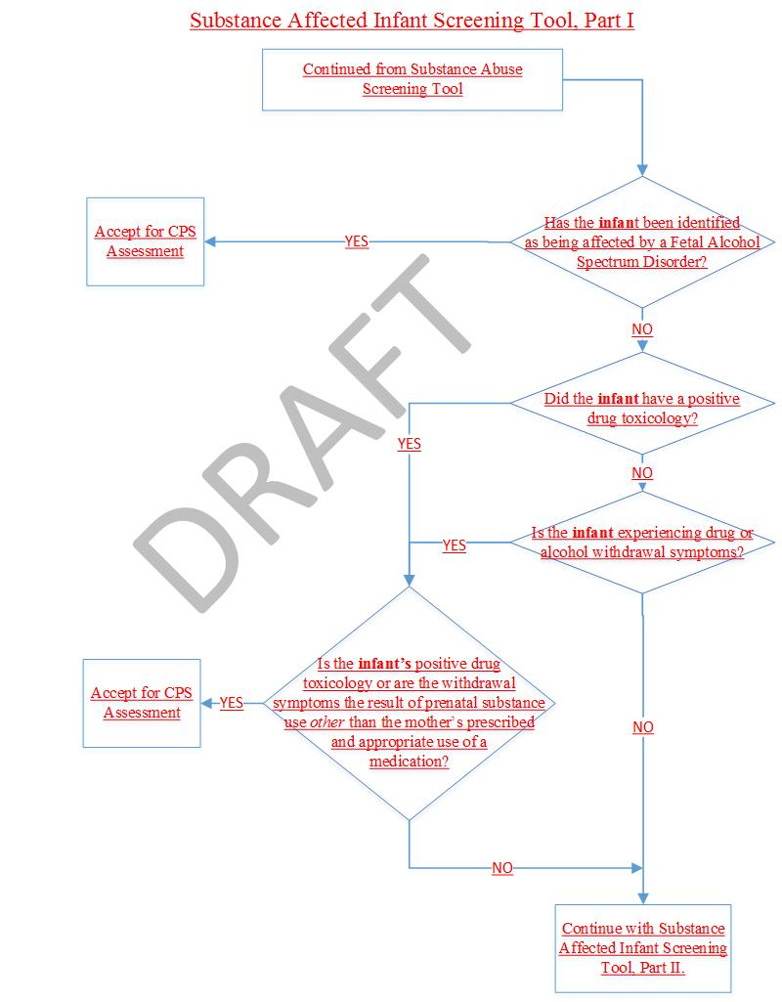

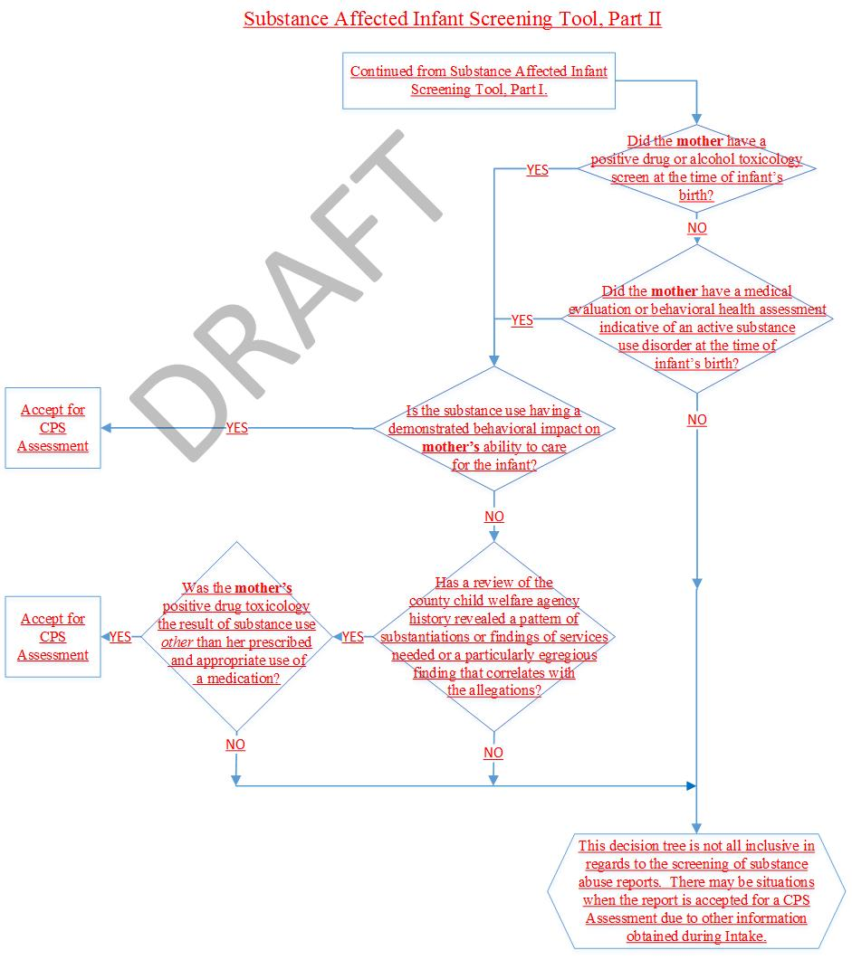

- Substance Affected Infant Screening Tool Directions

Has the infant been identified as being affected by a Fetal Alcohol Spectrum Disorder?

Fetal Alcohol Spectrum Disorder (FASD) is an umbrella term that encompasses all disabilities caused by prenatal alcohol exposure.

If the infant has received one of the following diagnoses than the report must be accepted for CPS assessment: Fetal Alcohol Syndrome (FAS), Partial FAS (PFAS), Neurobehavioral Disorder associated with Prenatal Alcohol Exposure (NDPAE), Alcohol-Related Birth Defects (ARBD) or Alcohol-Related Neurodevelopmental Disorder (ARND).

Did the infant have a positive drug toxicology? Is the infant experiencing drug/alcohol withdrawal symptoms?

A report alleging that an infant had a positive drug toxicology or is experiencing withdrawal symptoms would be appropriate for CPS assessment. However, if it is known that the drug is a medication prescribed to the mother and is being used appropriately – per the prescribing provider – than the report should not be accepted on that basis alone. This includes medications prescribed for the treatment of opioid use disorders.

Did the mother have a positive drug or alcohol toxicology screen at the time of the infant’s birth?

A report in which the only allegation is the mother’s substance use would not be appropriate for CPS assessment. However, a CPS assessment must occur if she is also demonstrating behaviors that impact her ability to provide care to the infant.

Additionally, a CPS assessment must occur if a review of county child welfare agency history revealed a pattern of substantiations or findings of services needed or a particularly egregious finding that correlates with the allegations. However, a mother’s prescribed and appropriate use of medications should not be coupled with county child welfare agency history to justify the acceptance of a report.

Did the mother have a medical evaluation or behavioral health assessment that was indicative of an active substance use disorder at the time of the infant’s birth?

A report in which the only allegation is the mother’s substance use disorder would not be appropriate for CPS assessment. However, a CPS assessment must occur if she is also demonstrating behaviors that impact her ability to provide care to the infant.
DRAFT

